Project Design Phase-II
Data Flow Diagram & User Stories

Date | 25 February 2026
Team ID | LTVIP2026TMIDS81684
Project Name | Calculating Family Expenses using ServiceNow
Maximum Marks | 4 Marks

Data Flow Diagrams:

Example: (Simplified)
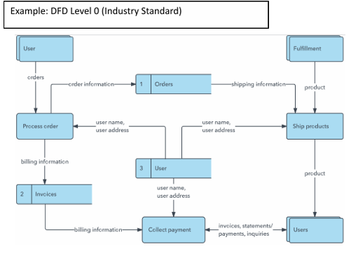
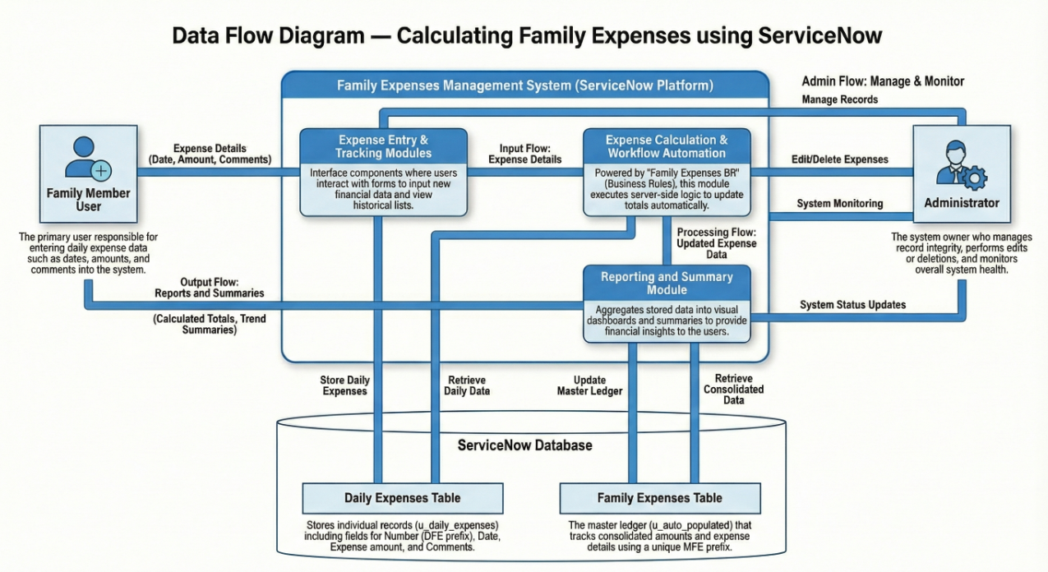
User Stories
Use the below template to list all the user stories for the product.
User Type | Functional Requirement (Epic) | User Story Number | User Story / Task | Acceptance Criteria | Priority | Release
Customer (Family Member) | Expense Management | USN-1 | As a user, I can add daily expenses with date, amount, and details | Expense record is saved successfully | High | Sprint-1
Customer (Family Member) | Expense Management | USN-2 | As a user, I can view all my expenses in the system | Expense list is displayed correctly | High | Sprint-1
Customer (Family Member) | Expense Tracking | USN-3 | As a user, I can see total expenses calculated automatically | Total amount updates when new expense is added | High | Sprint-1
Customer (Family Member) | Expense Tracking | USN-4 | As a user, I can view expenses grouped by date | Expenses are grouped correctly | Medium | Sprint-2
Customer (Family Member) | Reporting | USN-5 | As a user, I can check expense details summary | Summary is visible with correct data | Medium | Sprint-2
Administrator | System Management | USN-6 | As an admin, I can manage expense records | Admin can create, edit, delete records | High | Sprint-1

